

PETROL PUMP MANAGEMENT SYSTEM


December 20, 2021




PETROL PUMP MANAGEMENT SYSTEM

Project Exhibition -I

Submitted in partial fulfillment for the award of the degree of

Bachelor of Technology In
COMPUTER SCIENCE AND ENGINEERING

Submitted to

VIT BHOPAL UNIVERSITY (M.P.)

Submitted by

ABHISHEK THAPLIYAL 20BCE10231
ANIKET KHARE 20BCE10363
UTKARSH KUMAR 20BCE10622
SNEHA AGARWAL 20BCE10635
GAURAV SAHU 20BCE11043

Under the Supervision of

Prof. Manickavasagam

SCHOOL OF COMPUTER SCIENCE ENGINEERING

VIT BHOPAL UNIVERSITY
BHOPAL (M.P.)-466114
April-2022

A PROJECT REPORT

Submitted by

ABHISHEK THAPLIYAL 20BCE10231
ANIKET KHARE 20BCE10363
UTKARSH KUMAR 20BCE10622
SNEHA AGARWAL 20BCE10635
GAURAV SAHU 20BCE11043

in partial fulfillment for the award of the degree
of

BACHELOR OF TECHNOLOGY

in

COMPUTER SCIENCE AND ENGINEERING

SCHOOL OF COMPUTING SCIENCE AND ENGINEERING
VIT BHOPAL UNIVERSITY
KOTHRIKALAN, SEHORE
MADHYA PRADESH – 466114
December- 2021

VIT BHOPAL UNIVERSITY, KOTHRIKALAN, SEHORE
MADHYA PRADESH – 466114

BONAFIDE CERTIFICATE

Certified that this project report titled “PETROL PUMP MANAGEMENT SYSTEM” is the bonafide work of “ABHISHEK THAPLIYAL (20BCE10231),
ANIKET KHARE (20BCE10363) ,UTKARSH KUMAR (20BCE10622) ,SNEHA AGARWAL (20BCE10635) ,GAURAV SAHU (20BCE11043)” who carried out the project work under my supervision. Certified further that to the best of our knowledge the work reported at this time does not form part of any other project/research work based on which a degree or award was conferred on an earlier occasion on this or any other candidate.

PROGRAM CHAIR PROJECT GUIDE

Dr. Sandip Mal Mr.Manickavasagam
School of Computer Science and School of Computer Science and
Engineering Engineering

VIT BHOPAL UNIVERSITY VIT BHOPAL UNIVERSITY

The Project Exhibition I Examination is held on ______________

ACKNOWLEDGEMENT

First and foremost, I would like to thank the Lord Almighty for His presence and immense blessings throughout the project work.
I wish to express my heartfelt gratitude to Dr. Sandip Mal, Head of the Department, School of Aeronautical Science for much of his valuable support encouragement in carrying out this work.
I would like to thank my internal guide Mr. Manickavasagam, for continually guiding and actively participating in my project, giving valuable suggestions to complete the project work.
I would like to thank all the technical and teaching staff of the School of Aeronautical Science, who extended directly or indirectly all support.
Last, but not least, I am deeply indebted to my parents who have been the greatest support while I worked day and night for the project to make it a success.

List of Symbols & Abbreviations

PPMS:-  IEEE:-  I.E:-  ETC:- | Petrol Pump Management System  Institute of Electrical and Electronic Engineers  That is  Et Cetera
I/O:- | Input/output
&:- | And
IDE:- | Integrated development environment
LAN:- | Local Area Network
FPS:- | Frames Per Second
OS:- | Operating System
CPU:- | Central Processing Unit
RAM:- | Random-access memory
GPU:- | Graphics Processing Unit
CPP:- | C++ Language

LIST OF FIGURES AND GRAPHS

FIGURE NO. | TITLE | PAGE NO.
1 | Flow Diagram-1 | 23
2 | Flow Diagram-2 | 36
3 | Output of Source Code | 37
4 | Performance Analysis | 38

LIST OF TABLES
TABLE NO. | TITLE | PAGE NO.
1 | Table of Contents | 10

ABSTRACT

In present Petrol pump management System people use to maintain their sales detail, employee detail in files and folders. They use to keep the record of petrol and diesel sold, inventry, Customers, etc in a register. A daily register is maintained to keep track of sales. So Preparing report is very time consuming and tedious task. For searching of single record, whole register is to be searched which is very time consuming task. So tocut off all excess manual work we have developed a software that stores this entire data in a database and thus all the paper work are minimized.in our project we basically store all the data abut each and every vehicle that came at the station for any purpose either for servicing,tyres or refiling .our project focus mainly on reducing the man power and all the paper work so that chances of fraud in numbers can be minimized and a proper record can be maintained in a proper way so that data can be easily accessed in case of future references .this project tries to solve all the problems that are faced when the system was managed manually and tries to promote digitalization in every aspect. The main purpose of the project is that it is user friendly,easy to backup and maintains a high data security.

TABLE OF CONTENTS
CHAPTER NO. | TITLE | PAGE NO.
 | List of Abbreviations  List of Figures and Graphs  List of Tables  Abstract | iii  iv  v  vi
1 | CHAPTER-1:  PROJECT DESCRIPTION AND OUTLINE  Introduction  - Motivation for the work  1.3 Problem Statement  1.3.1 Solution  1.4 Objective of the work  1.5 Organisation of the project  1.6 Summary | 13  13  13  13  14.  14  14
2 | CHAPTER-2:  RELATED WORK INVESTIGATION  2.1 Introduction  2.2 Core area of the project  2.3 Existing Approaches/Methods  2.3.1 Manual Working  2.3.2 Faults in money counts  2.4 Pros and cons of the stated Approaches/Methods  2.5 Issues/observations from investigation  2.6 Summary | 15  15  15  16  16  16
3 | CHAPTER-3:  REQUIREMENT ARTIFACTS  3.1 Introduction  3.2 Hardware and Software requirements  3.2.1 Min. vs Recommended Requirements  3.3 Specific Project requirements  3.3.1 Data requirement  3.3.2 Functions requirement  3.3.3 Performance and security requirement  3.4 Summary | 17  17-18  18-20  21
4 | CHAPTER-4:  DESIGN METHODOLOGY AND ITS NOVELTY  4.1 Methodology  4.2 Goal of the project  4.3 Novelty of the project  4.4 Flow Diagram  4.6 Summary | 22  22  22  23  23
5 | CHAPTER-5:  TECHNICAL IMPLEMENTATION & ANALYSIS  5.1 Outline  5.2 Technical coding and code solutions  5.3 Flow Diagram  5.4 Output of the source code  5.5 Performance Analysis  5.6 Summary | 24  24-35  36  36-37  37-38  38
6 | CHAPTER-6:  PROJECT OUTCOME AND APPLICABILITY  6.1 Outcome  6.2 Applicability  6.3 Real World Usage  6.4 Inference | 39  39  39-40  40
7 | CHAPTER-7:  CONCLUSIONS AND RECOMMENDATION  7.1 Outline  7.2 Limitation/Constraints of the System  7.3 Future Enhancements  7.4 Inference | 41  41  41  42
 | References | 44

CHAPTER-1
PROJECT DESCRIPTION AND OUTLINE

  - INTRODUCTION

- The idea of our Petrol pump management system is mainly to manage daily records of petrol pump.
- Using this system the admin will be able to check the employee attendance, quantity of petrol and diesel sold in any day, week or month.
- We can also set the rating for petrol and diesel for that day as we know that it varies from day to day.
- User can generate reports easily form this petrol pump management system.

  - MOTIVATION FOR THE WORK

Motivation can inspire, encourage, and stimulate individuals and project teams to achieve great accomplishments. Motivation can also create an environment that fosters teamwork and collective initiatives to reach common goals or objectives. The level of motivation an individual and team applies to project efforts can affect all aspects of project results, including a direct impact to the triple constraint project success factors (i.e., on time, within budget, high quality, met scope / user’s expectations). The main motivation behind this project is to solve a regularly faced real time world and this will save time and efforts of many individuals.

  - PROBLEM STATEMENT

The traditional methods of managing a Petrol Pump is not a easy job. It is very time consuming, requires to keep records manually and there can be human calculation errors. So, in order to get rid of these challenges a Petrol Pump Management System can be a very useful tool.

    - SOLUTION

As the work at petrol pump is done manually so it becomes hard for the supervisor to maintain a
daily record. So we have developed this system to computerize all the reporting work of petrol
pump.
From report module admin can also generate several reports like pumps daily earning report ,
employee shift delivery report , pumps report , cumulative daily report , salary report, amount of
fuel sold . Admin can update many information in the system that’s why his account is protected
with user name and password. Only authentic user can login to admin account.

  - OBJECTIVE OF THE WORK

- To make a software which is easy to use.
- To improve the present Petrol Pump Management System.
- To check the quantity of fuel.
- To minimize manual calculation.
- Getting information related to sales on daily basis.

  - ORGANIZATION OF THE PROJECT

There is no single organizational approach to projects. Each project is organized to accomplish the work effectively and efficiently. Several factors influence the organizational approach to execute a project. The complexity profile of a project, the culture of the parent organization, the preferences of the project manager, the knowledge and skills of the team, and a parent organization with a project management office are examples of factors that influence the project’s organization. The project was organized and made successful with the help of all team members working together with coordination and give their time efforts and knowledge. The project includes a C++ code and was made many changes by all members.

1.6 SUMMARY

The main aim of our project is to make the management of petrol pump easier, as the traditional methods of managing petrol pump are very hectic and may cause errors in calculations of total transactions of a petrol pump.
So this software will not only make it easier to manage a petrol pump but will also minimize calculation errors and will save a lot of time and space .

CHAPTER-2
RELATED WORK INVESTIGATION

  - INTRODUCTION

In today’s world ,everything is getting digitalized whether it is in the field of payment ,shopping or for any other entertainment purpose.
But in this area related to petrol pump management system the entire system still remains the same that is entirely manual , so to minimize error we want to bring a change in this system and promote digitalization we came up with this system .
These project means that what the various activities are been carried out at the petrol system. In these project we will be including about how we can find out the information about the various petrol pump. Also in our project we will be including how we can find that which person has came when and when he will be going out.

  - CORE AREA OF THE PROJECT

We are working on the petrol pump management system and the problems faced by the owner and the people in keeping the entire records of the sales which are right now being handled entirely manually . so to improve the accessibility we are trying to convert manual work into database. As the work at petrol pump is done manually so it becomes hard for the supervisor to maintain a daily record. So for that we decide to make this project in which all the work is done with the help of one computer.

  - EXISTING APPROACHES/METHODS

    - MANUAL WORKING

In present system all report work is done manually at the petrol pump. Admin user have to check each petrol pump machine the calculate the sold petrol, but in our proposed system user can check sold petrol from his monitor by clicking on some report button. Admin can also check which employee sold how much petrol and what amount he submitted to accountant at the end of the day. Admin can also check how much oil they sold in one day or one month. Admin can generate monthly sale report or annually sale report when they want. This system also help admin to generate the salary of each employee on the basis of his position and working hour.

    - FAULTS IN MONEY COUNT

Since the entire system is operated by man power so chances of error are more and hence mistakes in numbers can easily be done .sometimes during refilling workers usually foul play in the amount and the quantity of the fuel and easily the customer is befooled . Since everthing is maintained manually so the chances of fraud are definitely high.

  - PROS AND CONS OF THE STATED APPROACHES/METHODS

PROS
v All the information about sale, purchase, stock will be maintain properly in this system.
v All manual calculation of sale or all the money management will be performed by the computer automatically.
v A database application can be stored in computer effectively.
v It is very user friendly

CONS
v As mentioned above most of details are maintained manually. Due to this the data retrieved is time consuming. Due to human calculation errors occur.
v Even when the data is maintained on spreadsheet inconsistency occurs as an order might be missed or wrongly entered or twice.
v Difficulty in managing multiple forms.
v Lack of security.

  - ISSUES/OBSERVATIONS FROM INVESTIGATIONS

After looking into the problem and the ways people are finding the solution of this every data faced problem somewhere shows that a permanent and effective solution is must needed. It deals with handling system problem. The feasibility study proposes one or more conceptual solutions to the problem set for the project. The conceptual solutions give an idea of what the system will look like. They define what will be done on the computer and what will remain manual. They also indicate what input will be needed by the system and what output will be produced by the system. Also it tells that whether the plan of the project is been made by the people.

  - SUMMARY

So, getting a solution of such problem feels like blessing and saves time and efforts of many individuals, so our code will really, be helpful to everyone whether it is for the supervisor,staff or for the customers .Everything will be crystal clear and chances of doing mistakes in the figres will be minimized.
CHAPTER-3
REQUIREMENT
ARTIFACTS

  - INTRODUCTION

- A requirement describes a condition or capability to which a system must conform.
- A requirement is either derived directly from user needs or stated in a contract, standard, specification, or other formally imposed document.
- For example, you can use features and use cases to describe the requirements, and then enhance the definition by creating diagrams, wireframes, or storyboards.
- Artifact is a general term for an object in a repository.
- You can manage artifacts in projects and folders, or you can use tags to filter groups of artifacts for a specific purpose.

  - HARDWARE AND SOFTWARE REQUIREMENTS

- System requirements are the required specifications a device must have in order to use certain hardware or software.
- For example, a computer may require a specific I/O port to work with a peripheral device. A smartphone may need a specific operating system to run a particular app.
- Software requirements for this system are as listed follows:--
- Operating system
- Minimum CPU or processor speed
- Minimum GPU or video memory
- Minimum system memory (RAM)
- Minimum free storage space

    - MINIMUM vs RECOMMENDED REQUIREMENTS

- Some products include both minimum and recommended system requirements.

- A video game, for instance, may function with the minimum required CPU and GPU, but it will perform better with the recommended hardware.

- A more powerful processor and graphics card may produce improved graphics and faster frame rates (FPS).

- Some system requirements are not flexible, such as the operating system(s) and disk space required for software installation.

- Others, such as CPU, GPU, and RAM requirements may vary significantly between the minimum and recommended requirements.

- When buying or upgrading a software program, it is often wise to make sure your system has close to the recommended requirements to ensure a good user experience.

- Below is an example of minimum versus recommended system requirements for a Windows application.
- OS: Windows 7 with SP1; (Recommended: Windows 10)
- CPU: Intel or AMD processor with 64-bit support; (Recommended: 2.8 GHz or faster processor)
- GPU: nVidia GeForce GTX 1050 or equivalent; (Recommended: nVidia GeForce GTX 1660 or Quadro T1000)
- Disk Storage: 4 GB of free disk space
- Monitor Resolution: 1280x800; (Recommended: 1920x1080)

  - SPECIFIC PROJECT REQUIREMENTS

- Imagine that you're building your dream house. You've purchased the land, hired the architect, and secured your construction crew. That's a good place to start, but without your blueprint, your dream house will remain just that: a dream. Your blueprint gives the architect, contractor, electrician, plumber, and anyone involved in the build, a clear idea of what needs to be done to finish the house. This plan provides them with the requirements needed to complete their jobs.
- Project requirements are conditions or tasks that must be completed to ensure the success or completion of the project.
- They provide a clear picture of the work that needs to be done. They're meant to align the project's resources with the objectives of the organization.
- The benefits of effectively gathering project requirements include cost reduction, higher project success rates, more effective change management, and improved communication among stakeholders.

    - DATA REQUIREMENTS

- Data requirements definition establishes the process used to identify, prioritize, precisely formulate, and validate the data needed to achieve business objectives.
- When documenting data requirements, data should be referenced in business language, reusing approved standard business terms if available.
- The main data that are required in our program are given as follow:
- Password of the program:
- Rate of petrol and diesel:
- Station location:
- Vehicle information (Car number)

    - FUNCTION REQUIREMENTS

Some important functions that we are going to use:-

1)void end() : It will show the ending page of the program when we choose to exit from
program.
2) void sale(): It will show the page which will show the total sales of that day when we exit
from the program before the ending page.
3) void start(): It will show the starting page of our program after we run and compile the
code. It is template of program introduction.
4) int service(): It will show the options that customers wanted to opt in servicing of car like
Washing, polishing, etc.
5) void entry(): It will show the main menu of program in which we can select what we
wanted to do for our like petrol, diesel, tyre, services, etc.
6) int tyers(): It will show options that what we wanted to do in tyre section of main menu
like buying tyres and tubes of vehicle.
7) void show(): It will show all the records of all the vehicles visited from the starting date of
pump.
8) void find(): It is used to find the record of a particular vehicle by the vehicle number.
9) void password(): In the start of program it will ask for password of the program.

After the construction of these function finally we will construct the int main() function of code by combining the these function with appropriate direction of way and hence completes our code.

    - PERFORMANCE AND SECURITY REQUIREMENTS

- Have you ever heard the old saying “You get what you get and you don’t get upset”? While that may apply to after-school snacks and birthday presents, it shouldn’t be the case for software security.
- Software owners don’t just accept any new software features that are deployed; features must go through a strategic process of critique, justification, and analysis before being deployed.
- Your teams should treat security with the same attention to detail. After all, secure software doesn’t just happen out of nowhere—it has to be a requirement of the strategic development process.
- To deploy secure software effectively, you need clear, consistent, testable, and measurable software security requirements.
- To build good requirements, make sure that you’re answering questions about your requirements.
- A software security requirement should be much like a functionality requirement; it shouldn’t be vague or unattainable. Anticipate developers’ questions and answer them ahead of time. Here’s how:
- Is this testable? Can we test this requirement in the final application? “Be secure” is not a testable requirement. “Encode all user-supplied output” is.
- Is this measurable? When we test for this, can we determine coverage and effectiveness?
- Is this complete? Are we forgetting something? Are we mandating checks for user-supplied data to databases but not logs?
- Is this clear? Will the people responsible for designing, implementing, testing, and delivering on this requirement understand the intent of the requirement?
- Is this unambiguous? Could someone interpret this requirement in any other ways?
- Are these requirements consistent? Are we approaching each security requirement in the same way to ensure that the security measures are applied consistently across the board?

  - SUMMARY

- Artifact is highly associated and related to specific methods or processes of development. Methods or processes can be project plans, business cases, or risk assessments.
- Distinct gathering and collections of detailed information are generally organized and incorporated into artifact sets. A set generally represents complete aspect of system.
- This is simply done to make development and establishment of complete software system in manageable manner.
- Many artifact types are included in the sample project templates, including these types:

1) Requirements.
2) Use cases.
3) Design documents.
4) Business process diagrams.
5) Use case diagrams.
CHAPTER-4
DESIGN METHODOLOGY AND ITS NOVELTY

  - METHODOLOGY

C++ code that will run and compile. It will ask about current rates of fuel and what services
customer are looking for and create records that will reduce manual records thus minimizing
chances of error and fraud . This system will be password protected and only petrol pump
admin can access records and edit fuel prices . The customer’s vehicle number will be noted and he can request fuels in terms of quantity as well as for a given amount , These sales will be recorded using the software . We will run this software using Turbo C++ .

  - GOAL OF THE PROJECT

Our goal is to create a simple and easy to use software that will benefit petrol pump management by being simple yet effective and would reduce the hassle of creating manual records and get complete error free records every day .

  - NOVELTY OF THE PROJECT

Our system will reduce human calculations and chances of error , all the information regarding prices ,sales along with registration number of vehicles serviced will be maintained properly in this system , As it is software based all the data can be stored locally in the device’s storage , so no bulky registers of records need to kept around . It will provide timely and precise reports .

  - FLOW DIAGRAM

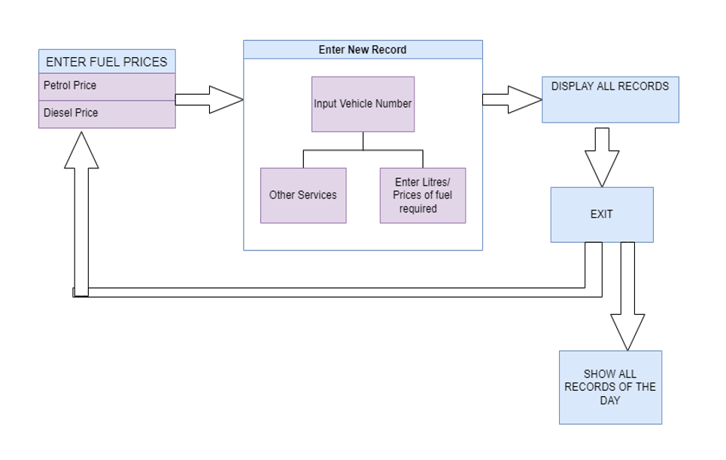

  - SUMMARY

To Summarize , our design methodology is to create simple software created using C++ that will take care of the needs required to keep records in a petrol pump ,it fulfils our goal of keeping records of the petrol pump in a hassle free and simple way and on top of that it has various advantages i.e, It is safe and dynamic as it takes care of fluctuating fuel rates as it allows admin to change fuel rates at the start of the day and is password protected . It reduces human calculation as it creates records of sales itself and shows the total amount of fuel sold and total money earned, So in short this system can be very effective to keep records of a petrol pump
.

CHAPTER-5

TECHNICAL IMPLEMENTATION & ANALYSIS

  - OUTLINE

The code in written in Cpp language and TURBO C++ is used to extract data and run our code.

  - TECHNICAL CODING AND CODING SOLUTION

A system development project is likely to be feasible if it meets the user requirement. Here we have decided to use technical language called CPP The purpose behind this is that we are more familiar with this language and it is easily access by the other user. Also the code for writing this is very easy and we can get the information in many books. Also it deal with knowledge of current and emerging technology solutions. Also there are several coding which we have done that will be very useful in terms of technical term. It is concerned with the capacity of the proposed system to meet initial performance expectation and accommodate new functionality over the medium term.
Some important functions that we are going to use:

1) void end() : It will show the ending page of the program when we choose to exit from program.
void pump::end()
{
textmode(C40);
textcolor(15);
int i;
for (i = 1; i <= 40; i++)
{
gotoxy(i, 1);
cprintf("*");
//delay(40);
}
for (i = 2; i <= 23; i++)
{
gotoxy(40, i);
cprintf("*");
//delay(40);
}
for (i = 40; i >= 1; i--)
{
gotoxy(i, 24);
cprintf("*");
//delay(40);
}
for (i = 23; i >= 2; i--)
{
gotoxy(1, i);
cprintf("*");
//delay(40);
}
delay(300);
textcolor(WHITE);

gotoxy(6, 8);
cprintf("T H A N K S F O R U S I N G");
gotoxy(16, 10);
cprintf("T H I S");
gotoxy(12, 12);
cprintf("S O F T W A R E");
gotoxy(8, 22);
textcolor(WHITE + BLINK);
cprintf("Press any key to exit ...");
getch();
textmode(C80);
}

2) void sale(): It will show the page which will show the total sales of that day when we exit from the program before the ending page.
void pump::sale(float totpet, float totrspet, float totdis, float totrsdis,
float tlubric, float trslubric, int tlubricpak, float trslubricpak,
int totservice, float trsservice, int tottyer, float trstyer)
{
clrscr();
float sale = 0;
sale = totrspet + totrsdis + trslubric + trslubricpak + trsservice + trstyer;
gotoxy(30, 2);
textcolor(4);
cprintf("TODAY'S SALE ");
gotoxy(29, 3);
cprintf("--------------");
gotoxy(14, 5);
textcolor(3);
cprintf("ITEM RUPEES");
gotoxy(14, 6);
cprintf("----- --------");
gotoxy(12, 8);
textcolor(14);
cprintf("PETROL ");
gotoxy(62, 8);
cprintf("%.2f", totrspet);
gotoxy(12, 10);
cprintf("DIESEL ");
gotoxy(62, 10);
cprintf("%.2f", totrsdis);
gotoxy(12, 12);
cprintf("LUBRICANT 1) LITERS");
gotoxy(62, 12);
cprintf("%.2f", trslubric);
gotoxy(21, 13);
cprintf(" 2) PACKETS ");
gotoxy(62, 13);
cprintf("%.2f", trslubricpak);
gotoxy(12, 15);
cprintf("VEHICLES SERVICE");
gotoxy(62, 15);
cprintf("%.2f", trsservice);
gotoxy(12, 17);
cprintf("TYERS");
gotoxy(62, 17);
cprintf("%.2f", trstyer);
gotoxy(10, 19);
cprintf("--------------------------------------------------------");
gotoxy(51, 21);
textcolor(5);
cprintf("CASH : ");
cprintf("%.2f", sale);
gotoxy(50, 22);
cprintf("-----");
gotoxy(60, 24);
textcolor(15);
cprintf("press any key...");
getch();
}

3) void start(): It will show the starting page of our program after we run and compile the code. It is the template of program introduction.
void pump::start()
{
textmode(C40);
char a[10][42];
textcolor(15);
strcpy(a[1], "A S O F T W A R E D E V L O P E D ");
strcpy(a[2], "F O R");
strcpy(a[3], " ");
strcpy(a[4], "PETROL PUMP MANAGEMENT SYSTEM");
strcpy(a[5], " ");
strcpy(a[6], " ");
int r = 4;
for (int j = 1; j <= 6;j++)
{
int l = strlen(a[j]);
int x = ((40 - l) / 2) + 1;
gotoxy(x, r);
for (int p = 0; p < l; p++)
{
putch(a[j][p]);
//delay(60);
}

delay(20);
if (j == 7)
textcolor(7 + BLINK);
else
textcolor(WHITE);
r = r + 2;
if (j == 5)
r = r + 2;
}
textcolor(WHITE + BLINK);
gotoxy(13, 24);
cprintf("WAIT FOR MOMENT...");
textcolor(WHITE);
delay(1000);
textmode(C80);
}
4) int service(): It will show the options that customers wanted to opt in servicing of car like Washing,polishing, etc.
int pump::service()
{
int ch, ch1, charg;
clrscr();
gotoxy(37, 3);
textcolor(2);
cprintf("SERVICES");
gotoxy(37, 4);
cprintf("--------");
gotoxy(10, 6);
textcolor(6);
cprintf("Enter [ 1 ] For Washing ");
gotoxy(10, 7);
cprintf("Enter [ 2 ] For Internal Cleaning ");
gotoxy(10, 8);
cprintf("Enter [ 3 ] For Washing and Polishing ");
gotoxy(10, 10);
textcolor(14);
cprintf("Enter Your choice (1 or 2 or 3) :: ");
cin >> ch;
clrscr();
switch (ch)
{
case 1:
gotoxy(10, 7);
textcolor(6);
cprintf("Enter [ 1 ] For Two Wheeler ");
gotoxy(10, 8);
cprintf("Enter [ 2 ] For Four Wheeler ");
gotoxy(10, 10);
textcolor(14);
cprintf("Enter Your choice (1 or 2) :: ");
cin >> ch1;
if (ch1 == 1)
charg = 30;
else
charg = 80;
gotoxy(10, 13);
textcolor(5);
cprintf("Washing Charges :: Rs ");
cout << charg;
break;
case 2:
charg = 150;
gotoxy(10, 13);
textcolor(5);
cprintf("Inner Cleaning Charges :: Rs ");
cout << charg;
break;
case 3:
gotoxy(10, 7);
textcolor(6);
cprintf("Enter [ 1 ] For Two Wheeler \n");
gotoxy(10, 9);
cprintf("Enter [ 2 ] For Four Wheeler\n");
gotoxy(10, 11);
textcolor(14);
cprintf("Enter Your Choice (1 or 2) :: ");
cin >> ch1;
if (ch1 == 1)
charg = 50;
else
charg = 120;
gotoxy(10, 15);
textcolor(5);
cprintf("Washing and Polishing charges :: Rs ");
cout << charg;
break;
}
return (charg);
getch();
}

5) void entry(): It will show the main menu of program in which we can select what we wanted to do for our like petrol, diesel, tyre, services, etc.
void pump::entry(float x, float y, char *xx)
{
gotoxy(37, 1);
textcolor(4);
cprintf("MENU");
gotoxy(36, 2);
cprintf("------");
gotoxy(27, 3);
textcolor(2);
cprintf("VEHICLE NUMBER :: ");
cout << xx;
gotoxy(10, 5);
textcolor(14);

cprintf("RATE OF PETROL :: Rs ");
cout << setprecision(2) << x;
gotoxy(45, 5);
textcolor(14);

cprintf("RATE OF DIESEL :: Rs ");
cout << setprecision(2) << y;
gotoxy(30, 8);
textcolor(5);

cprintf("ENTER [ 1 ] FOR PETROL ");
gotoxy(30, 10);
cprintf("ENTER [ 2 ] FOR DIESEL ");
gotoxy(30, 12);
cprintf("ENTER [ 3 ] FOR TYERS ");
gotoxy(30, 14);
cprintf("ENTER [ 4 ] FOR SERVICE ");
gotoxy(30, 16);
cprintf("ENTER [ 5 ] FOR LUCBRICANTS ");
gotoxy(30, 18);
cprintf("ENTER [ 6 ] FOR DISPLAY CURRENT RECORD ");
gotoxy(30, 20);
cprintf("ENTER [ 7 ] FOR EXIT FROM CURRENT RECORD ");
gotoxy(30, 24);
textcolor(14);

cprintf("Enter Your choice :: ");

6) int tyres(): It will show options that what we wanted to do in tyre section of main menu like buying
Tyres and tubes of vehicle.
int pump::tyers()
{
int ty, choice, tb;
float rt, amount, amount1, rtb, charg;
textcolor(6);
gotoxy(5, 3);
cprintf("Enter [ 1 ] For New Tyre ");
gotoxy(5, 4);

cprintf("Enter [ 2 ] For Tube ");
gotoxy(5, 5);
cprintf("Enter [ 3 ] For Tyre and Tube ");
textcolor(14);
gotoxy(5, 7);
cprintf("Enter your choice (1 or 2 or 3) :: ");
cin >> choice;
switch (choice)
{
case 1:
textcolor(14);
clrscr();
gotoxy(5, 3);
cprintf("Enter no of tyers you want to buy :: ");
cin >> ty;
gotoxy(5, 4);
cprintf("Cost per tyre :: Rs ");
cin >> rt;
amount = ty * rt;
textcolor(5);
gotoxy(5, 6);
cprintf("The cost of ");
cout << ty;
cprintf(" tyers is :: Rs ");
cprintf("%.2f", amount);
break;
case 2:
textcolor(14);
clrscr();
gotoxy(5, 3);
cprintf("How many tubes want to buy :: ");
cin >> tb;
gotoxy(5, 4);
cprintf("Cost per tube :: Rs ");
cin >> rtb;
amount = tb * rtb;
textcolor(5);
gotoxy(5, 6);
cprintf("The cost of ");
cout << tb;
cprintf(" tube is :: Rs ");
cprintf("%.2f", amount);
break;
case 3:
textcolor(14);
clrscr();
gotoxy(5, 3);
cprintf("Enter no of tyers you want to buy :: ");
cin >> ty;
gotoxy(5, 4);
cprintf("Cost of one tyre :: Rs ");
cin >> rt;
amount1 = ty * rt;
textcolor(5);
gotoxy(5, 5);
cprintf("The cost of ");
cout << ty;
cprintf(" tyers is :: Rs ");
cprintf("%.2f", amount1);
textcolor(14);
gotoxy(5, 7);
cprintf("How many tubes want to buy :: ");
cin >> tb;
gotoxy(5, 8);
cprintf("Cost per tube :: Rs ");
cin >> rtb;
charg = tb * rtb;
textcolor(5);
gotoxy(5, 9);
cprintf("The cost of ");
cout << tb;
cprintf(" tubes is :: Rs ");
cprintf("%.2f", charg);

amount = charg + amount1;
textcolor(5);
gotoxy(5, 12);
cprintf("Total charges for ");
cout << ty;
cprintf(" tyer and ");
cout << tb;
cprintf("tube :: Rs ");
cprintf("%.2f", amount);
break;
}
return (amount);
}

7) void show(): It will show all the records of all the vehicles visited from the starting date of pump.
void pump::show()
{
clrscr();
fstream file;
file.open("p.dat", ios::in, ios::out);
file.seekg(0, ios::beg);
int row = 3;
int flag = 0;
char ch;
gotoxy(1, 1);
textcolor(3);
cprintf("S NO. VEHICLE NUMBER WORK DONE QTY CHARGES");
gotoxy(1, 2);
cprintf("---------------------------------------------------------------------------------");
while (file.read((char *)&petrol, sizeof(petrol)))
{
_setcursortype(_NOCURSOR);
flag = 0;
delay(100);

gotoxy(3, row);
textcolor(14);
cprintf("%d", sno);
gotoxy(8, row);
cprintf("%s", no);
gotoxy(33, row);
cprintf("%s", item);
gotoxy(50, row);
cprintf("%.2f", qty);

gotoxy(71, row);
cprintf("%.2f", charg);

if (row == 23)
{
flag = 1;
row = 3;
gotoxy(17, 25);
textcolor(15);
cprintf("Press any key to go back to MAIN MENU....");
ch = getch();
if (ch == 27)
break;
clrscr();
gotoxy(1, 1);
textcolor(3);
cprintf("S NO. VEHICLE NUMBER WORK DONE QTY CHARGES ");
gotoxy(1, 2);
cprintf("------------------------------------------");
}
else
row = row + 2;
}
if (!flag)
{
gotoxy(20, 25);
textcolor(15);
cprintf("Press any key to go back to MAIN MENU....");
getch();
}
file.close();
}
//////////////////////////////////////////////////////////////////////////////////////
void pump::getdata(char *no2, int sno1, char *item1, float qty1, float charg1)
{
strcpy(no, no2);
sno = sno1;
strcpy(item, item1);
qty = qty1;
charg = charg1;
}
//////////////////////////////////////////////////////////////////////////////////////

void pump::bill(char *no, float litpet, float cpet, float litdis, float cdis, float lubric, float clubric, int pak, float cpak, int service, float cservice, float ctyer)
{

clrscr();
float sale = 0;
sale = cpet + cdis + clubric + cpak + cservice + ctyer;
gotoxy(27, 1);
textcolor(4);
cprintf("INDIA PETROL PUMP AND SERVICE STATION ");
gotoxy(26, 2);
cprintf("---------------------------------------");
gotoxy(30, 3);
textcolor(14);
cprintf("VECHICLE NUMBER # ");
cout << no;
gotoxy(14, 5);
textcolor(3);
cprintf("ITEM QUANTITY AMOUNT");
gotoxy(14, 6);
cprintf("----- ---------- --------");
gotoxy(12, 8);
textcolor(2);
cprintf("PETROL ");
gotoxy(37, 8);
cprintf("%.2f", litpet);
gotoxy(62, 8);
cprintf("%.2f", cpet);
gotoxy(12, 10);
cprintf("DIESEL ");
gotoxy(37, 10);
cprintf("%.2f", litdis);
gotoxy(62, 10);
cprintf("%.2f", cdis);

gotoxy(12, 12);
cprintf("LUBRICANT 1) LITERS");
gotoxy(37, 12);
cprintf("%.2f", lubric);
gotoxy(62, 12);
cprintf("%.2f", clubric);
gotoxy(21, 13);
cprintf(" 2) PACKETS ");
gotoxy(37, 13);
cprintf("%.2d", pak);
gotoxy(63, 13);
cprintf("%.2f", cpak);
gotoxy(12, 15);
cprintf("SERVICE");
gotoxy(37, 15);
cprintf("%2d", service);
gotoxy(62, 15);
cprintf("%4.2f", cservice);
gotoxy(12, 17);
cprintf("TYERS");
gotoxy(62, 17);
cprintf("%.2f", ctyer);
textcolor(3);
gotoxy(12, 19);
cprintf("-----------------------------------------------------------");
gotoxy(51, 21);
textcolor(5);
cprintf("CHARGES : ");
cprintf("%4.2f", sale);
gotoxy(50, 22);
cprintf("--------");
}

8) void find(): It is used to find the record of a particular vehicle by the vehicle number.
void pump::find()
{
char no1[15];
int y = 0;
fstream file;

clrscr();
file.open("p.dat", ios::in | ios::out);
file.seekg(0, ios::beg);
clrscr();
gotoxy(5, 6);
textcolor(14);
cprintf("ENTER VEHICLE NUMBER :: # ");
gets(no1);
for (int p = 0; no1[p] != '\0'; p++)
{
no1[p] = toupper(no1[p]);
}

file.read((char *)&petrol, sizeof(petrol));
while (!file.eof())
{
if (strcmp(no1, no) == 0)
{
y = 8;
clrscr();
gotoxy(16, 10);
textcolor(5);
cprintf("The record number is :: ");
cout << sno;
gotoxy(16, 12);
cprintf("Work done ");
cout << item;
gotoxy(16, 14);
cprintf("Charges ");
cprintf("%.2f", charg);
getch();
}
file.read((char *)&petrol, sizeof(petrol));
}
file.close();
if (y == 0)
{
gotoxy(30, 12);
textcolor(15);
cprintf("No entry of this number ");
}
}

9) void password(): In the start of program it will ask for password of the program
void pump::password()
{
char pass[10] = {"ppms"};
char pass1[10];
textmode(C40);
label:
gotoxy(10, 10);
textcolor(3);
cprintf("Enter password :: ");
textcolor(15);
gets(pass1);
gotoxy(10, 11);
delay(300);
if (!(strcmp(pass, pass1) == 0))
{
gotoxy(20, 19);
textcolor(5);
cprintf("Invalid password");
getch();
clrscr();
goto label;
}
gotoxy(20, 22);
textcolor(5);
cprintf("Correct password ");
delay(1000);
textmode(C80);
}

  - FLOW DIAGRAM

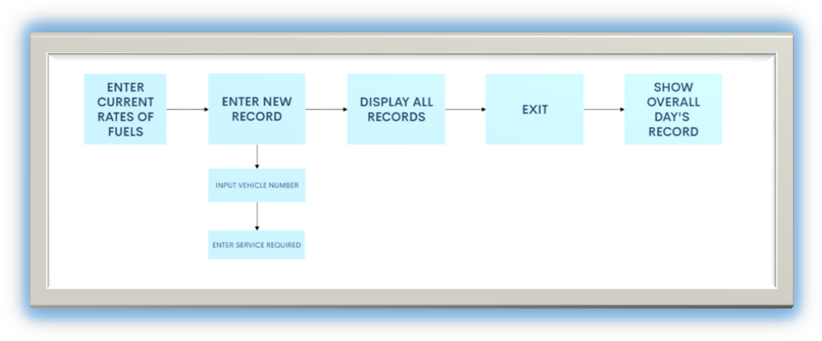

  - OUTPUT OF THE SOURCE CODE

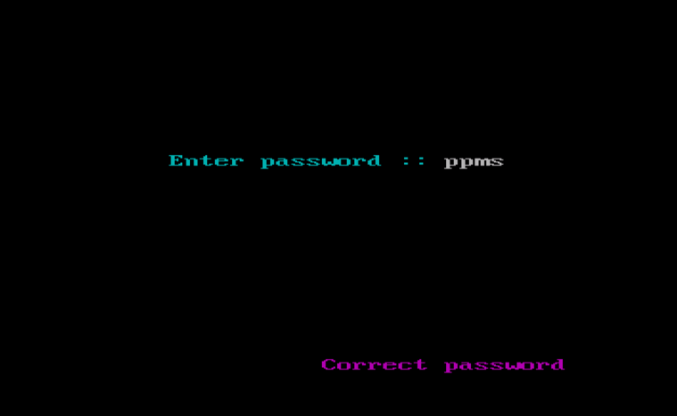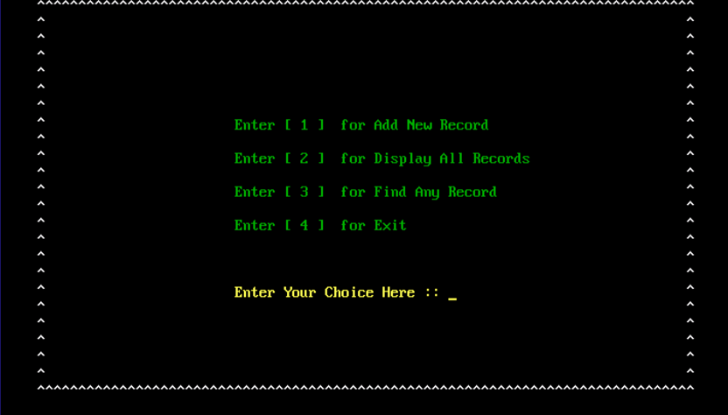

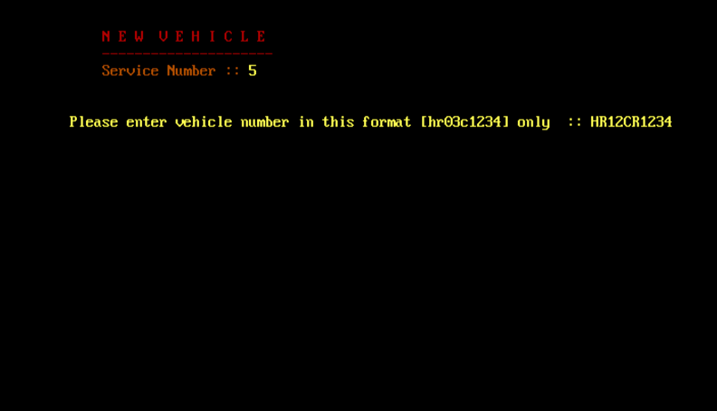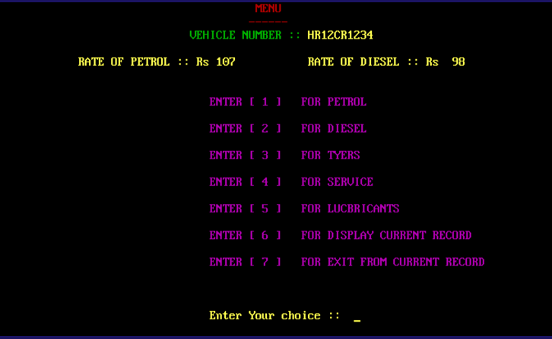

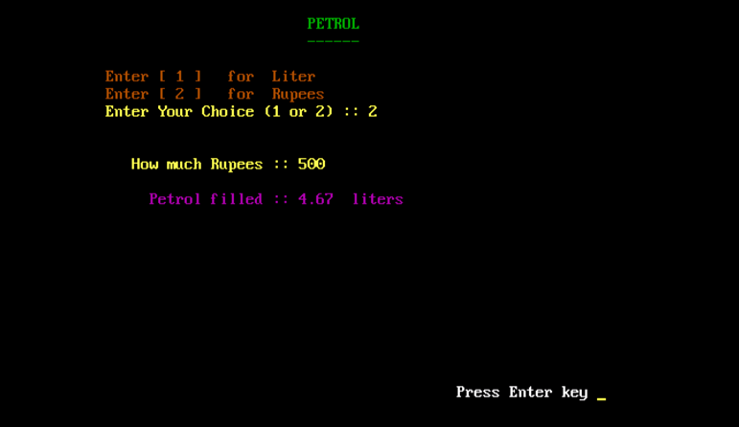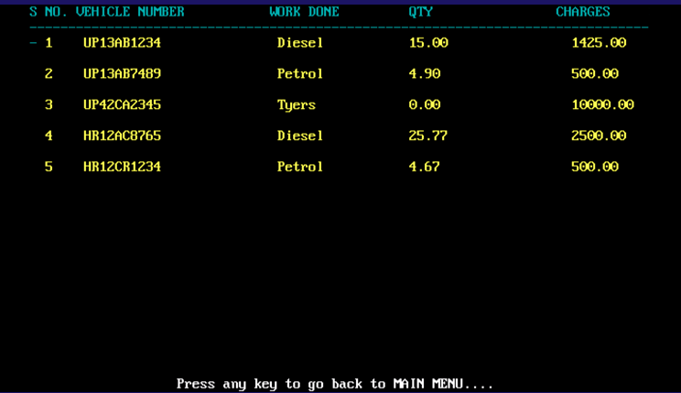

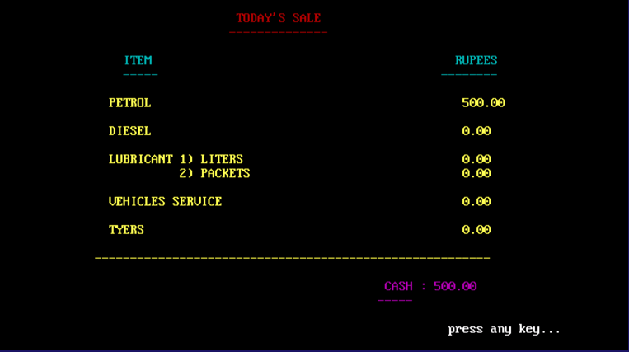

  - PERFORMANCE ANALYSIS

Analysis is a detailed of the various operation performed by the system and the relationship exist between the system. In our project we analysed the relationship that we will be using in our project.
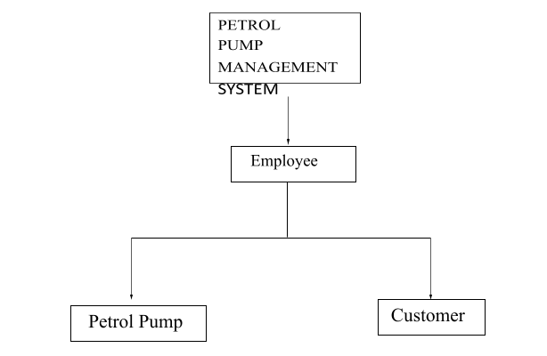
As soon as we run the code the file is password protected ,and opens only when the password is correct. When the user inputs the correct password the user is asked to enter price according to the current day and then the user moves further and registers the vehicle that came either for refilling, servicing or for any other facility .then as soon as the vehicle is registered the required work is done and final bill receipt is generated and while exiting the software entire day’s sale is shown to the user.

  - SUMMARY

The Current System is the manual one, hence is not speedy, accurate, efficient as well as time consuming. An essential part of the system analysis, which enables the developer to understand & the system correctly. It is undertaken to obtain details of the system. To understand the physical flow of the information through the current system. Collect various information through various fact finding techniques. Identify the procedural difficulties experienced by the user.

CHAPTER-6
PROJECT OUTCOME AND APPLICABILITY

  - OUTCOME

The main outcome of the “Petrol Pump Management System” is to make the management of petrol pump much easier. The Petrol pump management system is mainly to manage daily records of petrol pump. Using this system the admin will be able to check the employee attendance, quantity of petrol and diesel sold in any day, week or month.
We can also set the rating for petrol and diesel for that day as we know that it varies from day to day. User can generate reports easily form this petrol pump management system.

  - APPLICABILITY

(a) A database application can be stored in computer
effectively.
(b) No cheating in the numbers can be done.
(c)Whenever rates will fluctuate on time changes would
be made.
(d)Time management.
(e)No need to check manually the quantity left
(f)Cheating can be minimized

  - REAL WORLD USAGE

As we know usually the management of the petrol pump is done by the manager manually, so here we have developed Petrol pump management system.
This software is stand alone application useful for petrol pumps to this petrol pump management system will be .This will be useful for viewing all the information of the pump.
So overall our idea is to develop a software that help us from switching from manual work to database .So that less man force is required and glitches can be minimized.

  - INFERENCE

This software can be very useful and will certainly make managing a petrol pump a much easier job, as managing a petrol pump has always been a very difficult and hectic job. As manually
keeping records of everything is not as easy job and chances of error and cheating are much higher. So this software will reduce chances of errors, reduce the manforce required and will be eventurally reduce overall expenditure and save time.

CHAPTER-7

CONCLUSIONS & RECOMMENDATION

  - OUTLINE

The proposed system is computerized and has been developed using advance language therefore it gives more facilities than present system. It provides quick access to any data. In this system user have to enter the data only once and then it get linked with all files. This reduces the workload of user and it is also a time saving process. The information about any customer can be easily retrieved and the system maintains all records easy.

  - LIMITATIONS/CONSTRAINTS OF THE SYSTEM

- Fuel can easily dissipate, having excess quantities could lead to fuel loss for the pumps, costing them financially.
- The customer instructed to swipe credit card thorough card reader for verification and valid card will approved for transaction.
- Advanced Accounting with Analytics.
- The system must have efficiency and always respond to customer input within 2 minutes.
- The display should show a status message to customer when validating credit cards that the activity is in progress and not failed.
- the system should be easy to extend, so that any new payment option can be updated with minimal effort.

  - FUTURE ENHANCEMENT

Being a computer system, the system has good scope to be improved further.
Future Enhancements are as listed below:-

- Administrator can be given more rights so that he will be able to change order details.
- Employees daily sale records can be maintained individually
- Modifications can be done if any employee got promoted or left the job
- A system on LAN can be developed to setup the connection between other petrol pump of same company.

  - INFERENCE

. In this project we included about how we can find out the information about the various activities in a petrol pump. Also in our project we included how we can find that which person has came when and when he went out.
Also we can find that what is the amount received on a particular day. Also a person can find out what is the cost of the particular petrol, diesel, oil per liter.
Overall our System helps to store all the data about the customer order in computer and there is no need to do paper work and all the manual calculation errors can be minimized so that less man power can be utilized and the entie system works digitally using our software.

RELATED WORK INVESTIGATION

A typical code about petrol pump management was available on Google, the code had some errors if we directly try to run the code on ide such as TURBO C++, so after working on that code and making required changes we were able to run the code successfully.
There is many problems in the existing methods of managing petrol pump system, Due to which the petrol pump owners are facing financial losses and the existing methods are very time consuming as they require a lot of paper work.
So, as we made a software which can resolve these problems and all the data of a petrol pump will be stored in the software itself and all the calculations will be performed by the software.

REFERENCES
- https://www.freeprojectz.com/php-mysql-project/petrol-pump-management-system
- https://sites.google.com/site/ignoubcafinalyearprojects/project-report/petrol-pump-management-system-project-report
- https://code-projects.org/petrol-pump-management-system-in-c-with-source-code/

